Week 1: 3/11/25 | Week 2: 10/11/25 | Week 3: 17/11/25 | Week 4: 24/11/25 | Week 5: 1/12/25 | Week 6: 8/12/25 | Week 7: 15/12/25
Theme: Halloween | Theme: Remembrance. | Theme: Awesome Men – 19th November is International Men’s Day. | Theme: Non-fiction – November is Non-Fiction Month. | Theme: Time Travel – 8th December is Pretend to be a Time Traveller Day. | Theme: Christmas. | Theme: Christmas
Extracts:  - I Want to Be in a Scary Story (full PB).  - There’s a Troll in My Toilet (full PB). | Extracts:  - cBeebies Poppy Animation.  - Green Lizards vs Red Rectangles (full PB). | Extracts:  - CBBC Our Black History Heroes: Usain Bolt (TV clip).  - Mr Bolt (full PB). | Extracts:  - The Big Book of Beasts.  - The Big Book of Belonging.  - The Big Book of Bugs. | Extracts:  - T-Rex Time Machine: Dinos in De-Nile.  - The Dinosaur That Pooped the Past.  - Back to the Future. | Extracts:  - The Snowman (full movie). | Extracts:  - The Christmasaurus (full PB).
24 pieces of Tier 2 and Tier 3 vocabulary.  20 retrieval questions. | 13 pieces of Tier 2 and Tier 3 vocabulary.  15 retrieval questions. | 17 pieces of Tier 2 and Tier 3 vocabulary.  15 retrieval questions. | 15 pieces of Tier 2 and Tier 3 vocabulary.  15 retrieval questions. | 20 pieces of Tier 2 and Tier 3 vocabulary.  15 retrieval questions. | Daily vocabulary challenge.  15 retrieval questions. | 20 pieces of Tier 2 and Tier 3 vocabulary.  20 retrieval questions.
12 EXTENSION question to stretch learners. | 6 EXTENSION questions to stretch learners. | 9 EXTENSION questions to stretch learners. | 9 EXTENSION questions to stretch learners. | 8 EXTENSION questions to stretch learners. | 10 EXTENSION questions to stretch learners. | 12 EXTENSION questions to stretch learners.
Content Domains covered: 1a, 1b, 1c, 1d and 1e | Content Domains covered: 1a, 1b, 1c, 1d and 1e | Content Domains covered: 1a, 1b, 1c, 1d and 1e | Content Domains covered: 1a, 1b, 1c, 1d and 1e | Content Domains covered: 1a, 1b, 1c, 1d and 1e | Content Domains covered: 1a, 1b, 1c, 1d and 1e | Content Domains covered: 1a, 1b, 1c, 1d and 1e
Search: KS1 – Halloween Week  DIRECT LINK | Search: KS1 – Remembrance WCR – Green Lizards  DIRECT LINK | Search: KS1 – Awesome Men: Usain Bolt  DIRECT LINK | Search: KS1 – Non-Fiction November  DIRECT LINK | Search: KS1 – More Time-Travel Themed WCR  DIRECT LINK | Search: KS1 – Christmas WCR: The Snowman  DIRECT LINK | Search: KS1 – Christmas WCR: The Christmasaurus  DIRECT LINK
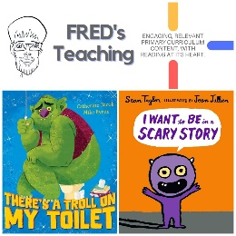 | 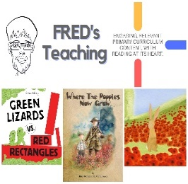 | 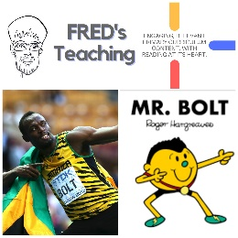 | 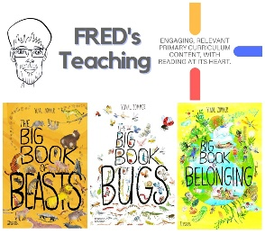 | 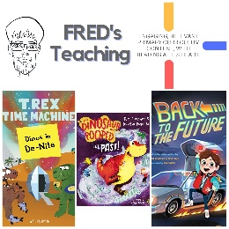 | 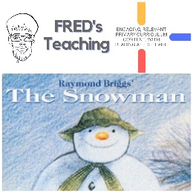 | 