Week 1: 1/9/25 | Week 2: 8/9/25 | Week 3: 15/9/25 | Week 4: 22/9/25 | Week 5: 29/9/25 | Week 6: 6/10/25 | Week 7: 13/10/25 | Week 8: 20/10/25
Theme: Summer Adventures | Theme: Roald Dahl – 13th September is Dahl Day! | Theme: Grandparents (Grandparents Day is in October). | Theme: Deaf Awareness – 22nd - 28th September is International Week of Deaf People. | Theme: Poetry – 2nd October is National Poetry Day. | Theme: Black History Month – Female Figures. | Theme: Black History Month – Space Scientists | Theme: Black History Month - Windrush
Extracts:  - Invisible Nature.  - You Can Get Active.  - 100 Great Walks With Kids. | Extracts:  - George’s Marvellous Medicine.  - James and the Giant Peach.  - The Gloriumptious World of Roald Dahl (NF). | Extracts:  - Grandpa Bert and the Ghost Snatchers.  - Grandpa was an Astronaut.  - I Lost My Granny in the Supermarket. | Extracts:  - El Deafo (TV Show Trailer on YouTube).  - El Deafo.  - Tomorrow (song featured in El Deafo). | Extracts:  - Chocolate Cake by Michael Rosen.  - Walking With My Iguana by Brian Moses.  - The Porcupine by Roald Dahl. | Extracts:  - Fantastically Great Women who Worked Wonders (NF).  - Fantastically Great Women who Made History (NF).  - Little Leaders: Bold Women in Black History (NF). | Extracts:  - Mae Among the Stars (NF).  - Work it Girl: Mae Jemison (NF).  - Inspiring Scientists: Maddie Aderin-Pocock (YouTube video). | Extracts:  - Coming to England (full PB).  - Coming to England.  - What is the Windrush Generation Newsround article (NF).
18 pieces of Tier 2 and Tier 3 vocabulary.  18 retrieval questions. | 19 pieces of Tier 2 and Tier 3 vocabulary.  18 retrieval questions. | 18 pieces of Tier 2 and Tier 3 vocabulary.  18 retrieval questions. | 19 pieces of Tier 2 and Tier 3 vocabulary.  18 retrieval questions. | 19 pieces of Tier 2 and Tier 3 vocabulary.  18 retrieval questions. | 21 pieces of Tier 2 and Tier 3 vocabulary.  18 retrieval questions. | 19 pieces of Tier 2 and Tier 3 vocabulary.  18 retrieval questions. | 19 pieces of Tier 2 and Tier 3 vocabulary.  18 retrieval questions.
12 EXTENSION question to stretch learners. | 11 EXTENSION questions to stretch learners. | 12 EXTENSION questions to stretch learners. | 12 EXTENSION questions to stretch learners. | 10 EXTENSION questions to stretch learners. | 11 EXTENSION questions to stretch learners. | 4 EXTENSION questions to stretch learners. | 8 EXTENSION questions to stretch learners.
Content Domains covered: 2a, 2b, 2c, 2d, 2e, 2f, 2g, 2h | Content Domains covered: 2a, 2b, 2c, 2d, 2e, 2f, 2g, 2h | Content Domains covered: 2a, 2b, 2c, 2d, 2e, 2f, 2g, 2h | Content Domains covered: 2a, 2b, 2c, 2d, 2e, 2f, 2g, 2h | Content Domains covered: 2a, 2b, 2c, 2d, 2e, 2f, 2g, 2h | Content Domains covered: 2a, 2b, 2c, 2d, 2e, 2f, 2g, 2h | Content Domains covered: 2a, 2b, 2c, 2d, 2e, 2f, 2g, 2h | Content Domains covered: 2a, 2b, 2c, 2d, 2e, 2f, 2g, 2h
Search: LKS2 Summer Adventure Planning  DIRECT LINK | Search: LKS2 Roald Dahl Week 1  DIRECT LINK | Search: LKS2 Grandparents Week 1  DIRECT LINK | Search: LKS2 Deaf Awareness 1  DIRECT LINK | Search: LKS2 Poetry Week: Male Poets  DIRECT LINK | Search: LKS2 Black History Month: Female Figures  DIRECT LINK | Search: LKS2 Black History Month: Mae Jemison  DIRECT LINK | Search: LKS2 Black History Month: Floella Benjamin  DIRECT LINK
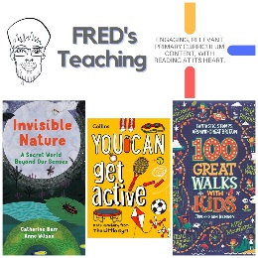 | 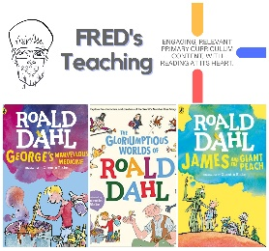 | 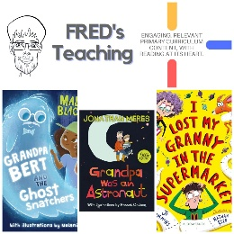 | 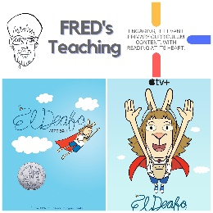 | 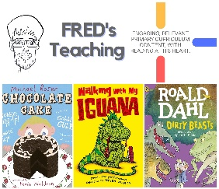 | 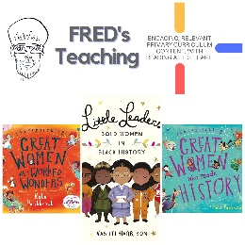 | 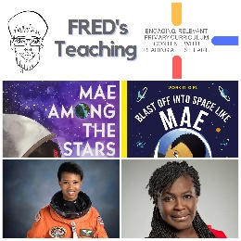 | 