Week 1: 3/11/25 | Week 2: 10/11/25 | Week 3: 17/11/25 | Week 4: 24/11/25 | Week 5: 1/12/25 | Week 6: 8/12/25 | Week 7: 15/12/25
Theme: Halloween | Theme: Remembrance. | Theme: Awesome Men – 19th November is International Men’s Day. | Theme: Non-fiction – November is Non-Fiction Month. | Theme: Time Travel – 8th December is Pretend to be a Time Traveller Day. | Theme: Christmas. | Theme: Christmas
Extracts:  - Scary Stories for 7-Year-Olds.  - Scary Poems to Make You Shiver.  - The Dark (PB extract). | Extracts:  - You Wouldn’t Want to be in the Trenches in WW1 (NF).  - Tail-end Charlie.  - The Story of WW1 (NF). | Extracts:  - Six Dots: A Story of Young Louis Braille (NF).  - Kids Britannica: Johannes Gutenberg (NF).  - William Shakespeare: Scenes from the Life (NF). | Extracts:  - Finding Home.  - Dinosaurs! Dinosaurs! Dinosaurs!  - Run Like a Girl! | Extracts:  - Forged in Steel.  - Aldrin Adams and the Cheese Nightmares.  - Time Travelling with a Hamster. | Extracts:  - Another Night Before Christmas.  - The Christmasaurus.  - Elf (movie trailer). | Extracts:  - The Tale of the Animals Christmas in Crouch End.  - A Boy Called Christmas (movie trailer).
21 pieces of Tier 2 and Tier 3 vocabulary.  18 retrieval questions. | 20 pieces of Tier 2 and Tier 3 vocabulary.  18 retrieval questions. | 22 pieces of Tier 2 and Tier 3 vocabulary.  18 retrieval questions. | 18 pieces of Tier 2 and Tier 3 vocabulary.  18 retrieval questions. | 18 pieces of Tier 2 and Tier 3 vocabulary.  18 retrieval questions. | 23 pieces of Tier 2 and Tier 3 vocabulary.  18 retrieval questions. | 18 pieces of Tier 2 and Tier 3 vocabulary.  18 retrieval questions.
12 EXTENSION questions to stretch learners. | 9 EXTENSION questions to stretch learners. | 12 EXTENSION questions to stretch learners. | 12 EXTENSION questions to stretch learners. | 5 EXTENSION questions to stretch learners. | 11 EXTENSION questions to stretch learners. | 12 EXTENSION questions to stretch learners.
Content Domains covered: 2a, 2b, 2c, 2d, 2e, 2f, 2g, 2h | Content Domains covered: 2a, 2b, 2c, 2d, 2e, 2f, 2g, 2h | Content Domains covered: 2a, 2b, 2c, 2d, 2e, 2f, 2g, 2h | Content Domains covered: 2a, 2b, 2c, 2d, 2e, 2f, 2g, 2h | Content Domains covered: 2a, 2b, 2c, 2d, 2e, 2f, 2g, 2h | Content Domains covered: 2a, 2b, 2c, 2d, 2e, 2f, 2g, 2h | Content Domains covered: 2a, 2b, 2c, 2d, 2e, 2f, 2g, 2h
Search: LKS2 – Halloween Week  DIRECT LINK | Search: LKS2 – Remembrance WCR: The Story of World War One  DIRECT LINK | Search: LKS2 – Awesome Men: Braille  DIRECT LINK | Search: LKS2 – Non-Fiction November  DIRECT LINK | Search: LKS2 – Time-Travel Themed WCR  DIRECT LINK | Search: LKS2 – Christmas WCR: The Christmasaurus and Elf  DIRECT LINK | Search: LKS2 – The Tale of the Animals’ Christmas in Crouch End  DIRECT LINK
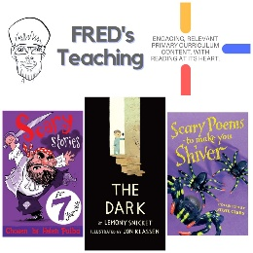 | 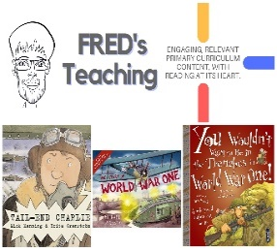 | 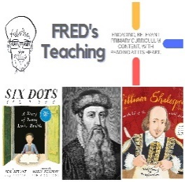 | 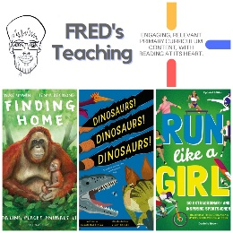 | 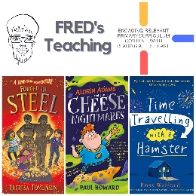 | 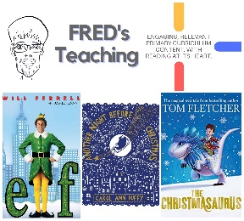 | 