Week 1: 3/11/25 | Week 2: 10/11/25 | Week 3: 17/11/25 | Week 4: 24/11/25 | Week 5: 1/12/25 | Week 6: 8/12/25 | Week 7: 15/12/25
Theme: Halloween. | Theme: Remembrance. | Theme: Awesome Men – 19th November is International Men’s Day. | Theme: Non-fiction – November is Non-Fiction Month. | Theme: Time Travel – 8th December is Pretend to be a Time Traveller Day. | Theme: Christmas. | Theme: Christmas
Extracts:  - Top Tips to Win at Trick or Treat (Newsround article).  - Horrid Henry’s Halloween Horrors.  - Monstacademy: The Halloween Parade. | Extracts:  - Daisy and the Unknown Warrior.  - Letters from the Lighthouse.  - Anne Frank’s Diary (Graphic Novel). | Extracts:  - Newsround article: Who Was Einstein (NF).  - Einstein’s Underpants.  - Max Einstein: The Genius Experiment. | Extracts:  - Finding Home.  - The Wild Life of Dinosaurs.  Run Like a Girl. | Extracts:  - The Accidental Time Travel.  - Tom’s Midnight Garden.  - Harry Potter and the Goblet of Fire (film clip). | Extracts:  - How Winston Delivered Christmas.  - The Night I Met Father Christmas.  - Jingle all the Way (movie trailer). | Extracts:  - The Christmasaurus and the Winter Witch.  - The Christmasaurus and the Naughty List.  - Klaus (movie trailer).
19 pieces of Tier 2 and Tier 3 vocabulary.  18 retrieval questions. | 21 pieces of Tier 2 and Tier 3 vocabulary.  18 retrieval questions. | 18 pieces of Tier 2 and Tier 3 vocabulary.  18 retrieval questions. | 18 pieces of Tier 2 and Tier 3 vocabulary.  18 retrieval questions. | 19 pieces of Tier 2 and Tier 3 vocabulary.  16 retrieval questions. | 22 pieces of Tier 2 and Tier 3 vocabulary.  18 retrieval questions. | 18 pieces of Tier 2 and Tier 3 vocabulary.  18 retrieval questions.
10 EXTENSION questions to stretch learners. | 8 EXTENSION questions to stretch learners. | 7 EXTENSION questions to stretch learners. | 12 EXTENSION questions to stretch learners. | 9 EXTENSION questions to stretch learners. | 11 EXTENSION questions to stretch learners. | 12 EXTENSION questions to stretch learners.
Content Domains covered: 2a, 2b, 2c, 2d, 2e, 2f, 2g, 2h | Content Domains covered: 2a, 2b, 2c, 2d, 2e, 2f, 2g, 2h | Content Domains covered: 2a, 2b, 2c, 2d, 2e, 2f, 2g, 2h | Content Domains covered: 2a, 2b, 2c, 2d, 2e, 2f, 2g, 2h | Content Domains covered: 2a, 2b, 2c, 2d, 2e, 2f, 2g, 2h | Content Domains covered: 2a, 2b, 2c, 2d, 2e, 2f, 2g, 2h | Content Domains covered: 2a, 2b, 2c, 2d, 2e, 2f, 2g, 2h
Search: LKS2 – More Halloween WCR  DIRECT LINK | Search: LKS2 – Remembrance WCR: Anne Frank’s Diary  DIRECT LINK | Search: LKS2 – Awesome Men: Einstein  DIRECT LINK | Search: LKS2 – More Non-Fiction November  DIRECT LINK | Search: LKS2 – More Time-Travel Themed WCR  DIRECT LINK | Search: LKS2 – Christmas WCR: The Night I Met Father Christmas  DIRECT LINK | Search: LKS2 – Christmas WCR: More Christmasaurus and Klaus  DIRECT LINK
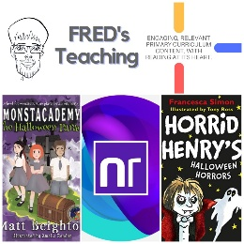 | 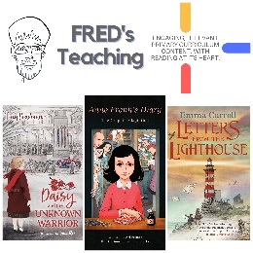 | 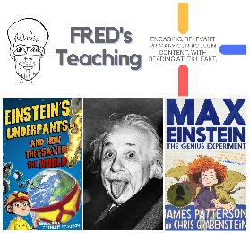 | 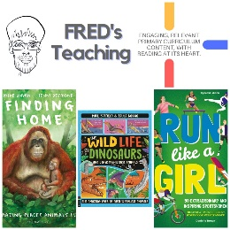 | 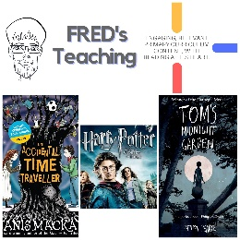 | 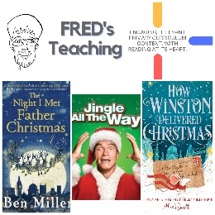 | 