Week 1: 1/9/25 | Week 2: 8/9/25 | Week 3: 15/9/25 | Week 4: 22/9/25 | Week 5: 29/9/25 | Week 6: 6/10/25 | Week 7: 13/10/25 | Week 8: 20/10/25
Theme: Summer Adventures. | Theme: Roald Dahl – 13th September is Dahl Day! | Theme: Grandparents (Grandparents Day is in October). | Theme: Deaf Awareness – 22nd – 28th September is International Week of Deaf People. | Theme: Poetry – 2nd October is National Poetry Day. | Theme: Black History Month – Katherine Johnson. | Theme: Black History Month – Black Britons and Windrush. | Theme: Black History Month – Young, Gifted and Black.
Extracts:  - You Can Have an Outdoor Adventure.  - Beach Explorer.  - Ultimate Mapping Guide for Kids. | Extracts:  - The Witches.  - Charlie and the Chocolate Factory.  - The Gloriumptious Worlds of Roald Dahl (NF). | Extracts:  - Grandpa Frank’s Great Big Bucket List.  - Check Mates.  - Pages and Co: Tilly and the Book Wanderers. | Extracts:  - Wonder Struck.  - Max and the Millions.  - Newsround article ‘Deaf Awareness Week’ (NF). | Extracts:  - What You Need to be Warm by Neil Gaiman.  - The British by Benjamin Zephaniah.  - Adventures of Isabel by Ogden Nash. | Extracts:  - The Extraordinary Life of Katherine Johnson (NF).  - Hidden Figures (Young Readers Edition).  - NASA Biography of Katherine Johnson (NF). | Extracts:  - Black and British (NF).  - Windrush Generation BBC News article (NF).  - Windrush Child. | Extracts:  - 3 extracts from the book Young, Gifted and Black (NF).  - Duvernay and Coleman.  - Adichie and Freeman.  - Carver and Blackman.
22 pieces of Tier 2 and Tier 3 vocabulary.  21 retrieval questions.  3 writing challenges. | 22 pieces of Tier 2 and Tier 3 vocabulary.  21 retrieval questions.  3 writing challenges. | 21 pieces of Tier 2 and Tier 3 vocabulary.  21 retrieval questions.  3 writing challenges. | 22 pieces of Tier 2 and Tier 3 vocabulary.  21 retrieval questions.  3 writing challenges. | 25 pieces of Tier 2 and Tier 3 vocabulary.  21 retrieval questions.  3 writing challenges. | 22 pieces of Tier 2 and Tier 3 vocabulary.  21 retrieval questions.  3 writing challenges. | 22 pieces of Tier 2 and Tier 3 vocabulary.  21 retrieval questions.  3 writing challenges. | 24 pieces of Tier 2 and Tier 3 vocabulary.  21 retrieval questions.  3 writing challenges.
17 EXTENSION questions to stretch learners. | 16 EXTENSION questions to stretch learners. | 18 EXTENSION questions to stretch learners. | 15 EXTENSION questions to stretch learners. | 7 EXTENSION questions to stretch learners. | 9 EXTENSION questions to stretch learners. | 11 EXTENSION questions to stretch learners. | 17 EXTENSION questions to stretch learners.
Content Domains covered: 2a, 2b, 2c, 2d, 2e, 2f, 2g, 2h | Content Domains covered: 2a, 2b, 2c, 2d, 2e, 2f, 2g, 2h | Content Domains covered: 2a, 2b, 2c, 2d, 2e, 2f, 2g, 2h | Content Domains covered: 2a, 2b, 2c, 2d, 2e, 2f, 2g, 2h | Content Domains covered: 2a, 2b, 2c, 2d, 2e, 2f, 2g, 2h | Content Domains covered: 2a, 2b, 2c, 2d, 2e, 2f, 2g, 2h | Content Domains covered: 2a, 2b, 2c, 2d, 2e, 2f, 2g, 2h | Content Domains covered: 2a, 2b, 2c, 2d, 2e, 2f, 2g, 2h
Search: UKS2 Summer Adventure Planning  DIRECT LINK | Search: UKS2 Roald Dahl Week 1  DIRECT LINK | Search: UKS2 Grandparents Week 1  DIRECT LINK | Search: UKS2 Deaf Awareness 1  DIRECT LINK | Search: UKS2 Poetry Week: Male Poets  DIRECT LINK | Search: UKS2 Black History Month: Katherine Johnson  DIRECT LINK | Search: UKS2 Black History Month: Black Britons and Windrush  DIRECT LINK | Search: UKS2 Black History Month: Young, Gifted and Black  DIRECT LINK
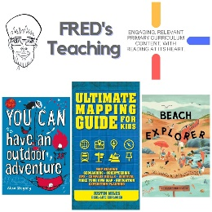 | 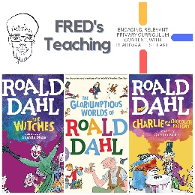 | 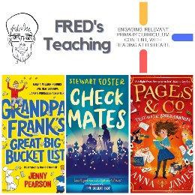 | 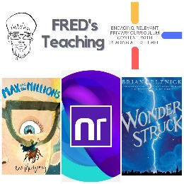 | 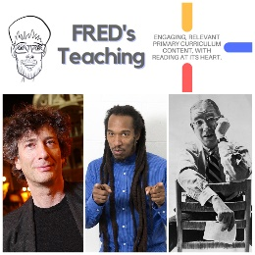 | 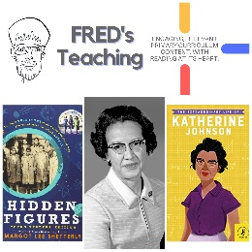 | 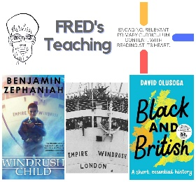 | 