Week 1: 3/11/25 | Week 2: 10/11/25 | Week 3: 17/11/25 | Week 4: 24/11/25 | Week 5: 1/12/25 | Week 6: 8/12/25 | Week 7: 15/12/25
Theme: Halloween. | Theme: Remembrance. | Theme: Awesome Men – 19th November is International Men’s Day. | Theme: Non-fiction – November is Non-Fiction Month. | Theme: Time Travel – 8th December is Pretend to be a Time Traveller Day. | Theme: Christmas. | Theme: Christmas
Extracts:  - A Dark, Dark Tale (full PB).  - Room 13.  - A Perfect Whitby Travel Guide (blog). | Extracts:  - Once.  - Then.  - Now. | Extracts:  - Little People, Big Dreams: David Attenborough (PB).  - A Life on Our Planet (NF).  Newsround Article: Young People (NF). | Extracts:  - Beach Explorer.  - Maps of the United Kingdom.  - Amazing Immortals. | Extracts:  - A Chase in Time.  - My Cousin is a Time Traveller.  - A Wrinkle in Time. | Extracts:  - A Boy Called Christmas.  - Mistletoe and Murder.  - Home Alone (movie trailer). | Extracts:  - Virtually Christmas.  - Diary of a Christmas Elf.  - Jingle Jangle (movie trailer).
18 pieces of Tier 2 and Tier 3 vocabulary.  21 retrieval questions.  3 writing challenges. | 22 pieces of Tier 2 and Tier 3 vocabulary.  21 retrieval questions.  3 writing challenges. | 24 pieces of Tier 2 and Tier 3 vocabulary.  21 retrieval questions.  3 writing challenges. | 24 pieces of Tier 2 and Tier 3 vocabulary.  21 retrieval questions.  3 writing challenges. | 24 pieces of Tier 2 and Tier 3 vocabulary.  21 retrieval questions.  3 writing challenges. | 22 pieces of Tier 2 and Tier 3 vocabulary.  21 retrieval questions.  3 writing challenges. | 21 pieces of Tier 2 and Tier 3 vocabulary.  21 retrieval questions.  3 writing challenges.
16 EXTENSION questions to stretch learners. | 18 EXTENSION questions to stretch learners. | 15 EXTENSION questions to stretch learners. | 18 EXTENSION questions to stretch learners. | 12 EXTENSION questions to stretch learners. | 15 EXTENSION questions to stretch learners. | 18 EXTENSION questions to stretch learners.
Content Domains covered: 2a, 2b, 2c, 2d, 2e, 2f, 2g, 2h | Content Domains covered: 2a, 2b, 2c, 2d, 2e, 2f, 2g, 2h | Content Domains covered: 2a, 2b, 2c, 2d, 2e, 2f, 2g, 2h | Content Domains covered: 2a, 2b, 2c, 2d, 2e, 2f, 2g, 2h | Content Domains covered: 2a, 2b, 2c, 2d, 2e, 2f, 2g, 2h | Content Domains covered: 2a, 2b, 2c, 2d, 2e, 2f, 2g, 2h | Content Domains covered: 2a, 2b, 2c, 2d, 2e, 2f, 2g, 2h
Search: UKS2 – Halloween Week Planning  DIRECT LINK | Search: UKS2 – World War Two WCR: Once Series  DIRECT LINK | Search: UKS2 – Awesome Men: Sir David Attenborough  DIRECT LINK | Search: UKS2 – Non-Fiction November  DIRECT LINK | Search: UKS2 – Time-Travel Themed WCR  DIRECT LINK | Search: UKS2 – Christmas WCR: A Boy Called Christmas  DIRECT LINK | Search: UKS2 – Christmas WCR: Virtually Christmas and Jingle Jangle  DIRECT LINK
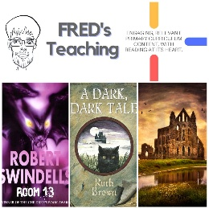 | 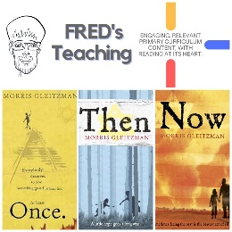 | 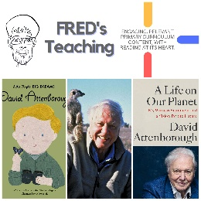 | 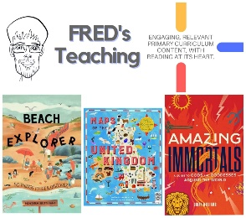 | 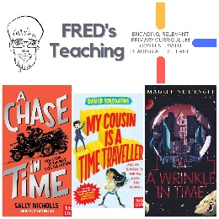 | 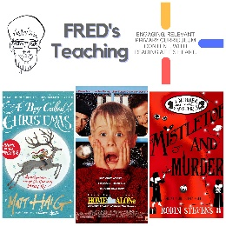 | 