Week 1: 1/9/25 | Week 2: 8/9/25 | Week 3: 15/9/25 | Week 4: 22/9/25 | Week 5: 29/9/25 | Week 6: 6/10/25 | Week 7: 13/10/25 | Week 8: 20/10/25
Theme: Summer Adventures. | Theme: Roald Dahl – 13th September is Dahl Day! | Theme: Grandparents (Grandparents Day is in October). | Theme: Deaf Awareness – 22nd – 28th September is International Week of Deaf People. | Theme: Poetry – 2nd October is National Poetry Day. | Theme: Black History Month – Michelle Obama. | Theme: Black History Month – Abolition of Slavery. | Theme: Black History Month – Inspirational novels.
Extracts:  - Atlas of Adventures: Wonders of the World.  - The Ordnance Survey Kids’ Adventure Book.  - Adventures on Earth. | Extracts:  - Matilda.  - The BFG.  - The Gloriumptious Worlds of Roald Dahl (NF). | Extracts:  - The Good Thieves.  - The House with Chicken Legs.  - Dragonfly Eyes. | Extracts:  - The Silent Striker.  - The Salt-Stained Book.  - Newsround article ‘Being a Deaf Ally’ (NF). | Extracts:  - One Vote by Aimee Nezhukumatathil.  - Resurrection by Sally Wen Mao.  - The Hill We Climb by Amanda Gorman. | Extracts:  - Work it Girl: Michelle Obama (NF PB).  - Becoming TV Trailer.  - Becoming (NF). | Extracts:  - Abolition of the Slave Trade Newsround article (NF).  - Freedom.  - Five Black Heroes of the Abolition Movement in Britain (NF). | Extracts:  - Respect.  - Journey to Jo’burg.  - How High the Moon.
22 pieces of Tier 2 and Tier 3 vocabulary.  21 retrieval questions.  3 writing challenges. | 22 pieces of Tier 2 and Tier 3 vocabulary.  21 retrieval questions.  3 writing challenges. | 22 pieces of Tier 2 and Tier 3 vocabulary.  21 retrieval questions.  3 writing challenges. | 21 pieces of Tier 2 and Tier 3 vocabulary.  21 retrieval questions.  3 writing challenges. | 26 pieces of Tier 2 and Tier 3 vocabulary.  21 retrieval questions.  3 writing challenges. | 23 pieces of Tier 2 and Tier 3 vocabulary.  14 retrieval questions plus question writing challenge.  3 writing challenges. | 21 pieces of Tier 2 and Tier 3 vocabulary.  21 retrieval questions.  3 writing challenges. | 22 pieces of Tier 2 and Tier 3 vocabulary.  21 retrieval questions.  3 writing challenges.
17 EXTENSION questions to stretch learners. | 17 EXTENSION questions to stretch learners. | 18 EXTENSION questions to stretch learners. | 14 EXTENSION questions to stretch learners. | 6 EXTENSION questions to stretch learners. | 9 EXTENSION questions to stretch learners. | 15 EXTENSION questions to stretch learners. | 18 EXTENSION questions to stretch learners.
Content Domains covered: 2a, 2b, 2c, 2d, 2e, 2f, 2g, 2h | Content Domains covered: 2a, 2b, 2c, 2d, 2e, 2f, 2g, 2h | Content Domains covered: 2a, 2b, 2c, 2d, 2e, 2f, 2g, 2h | Content Domains covered: 2a, 2b, 2c, 2d, 2e, 2f, 2g, 2h | Content Domains covered: 2a, 2b, 2c, 2d, 2e, 2f, 2g, 2h | Content Domains covered: 2a, 2b, 2c, 2d, 2e, 2f, 2g, 2h | Content Domains covered: 2a, 2b, 2c, 2d, 2e, 2f, 2g, 2h | Content Domains covered: 2a, 2b, 2c, 2d, 2e, 2f, 2g, 2h
Search: UKS2 More Summer Adventure Planning  DIRECT LINK | Search: UKS2 Roald Dahl Week 2  DIRECT LINK | Search: UKS2 Grandparents Week 2  DIRECT LINK | Search: UKS2 Deaf Awareness 2  DIRECT LINK | Search: UKS2 Poetry Week: Female Poets  DIRECT LINK | Search: UKS2 Black History Month: Michelle Obama  DIRECT LINK | Search: UKS2 Black History Month: The Abolition of Slavery  DIRECT LINK | Search: UKS2 Black History Month: Inspirational Novels  DIRECT LINK
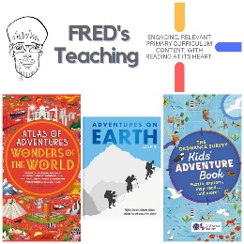 | 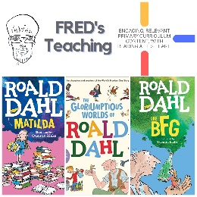 | 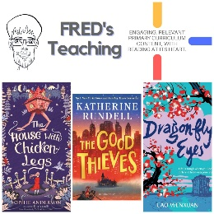 | 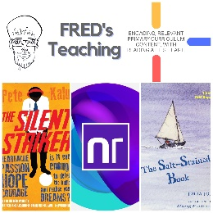 |  | 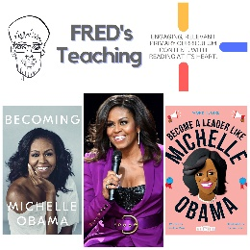 | 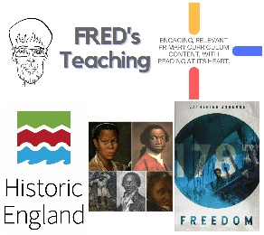 | 