Week 1: 3/11/25 | Week 2: 10/11/25 | Week 3: 17/11/25 | Week 4: 24/11/25 | Week 5: 1/12/25 | Week 6: 8/12/25 | Week 7: 15/12/25
Theme: Halloween. | Theme: Remembrance. | Theme: Awesome Men – 19th November is International Men’s Day. | Theme: Non-fiction – November is Non-Fiction Month. | Theme: Time Travel – 8th December is Pretend to be a Time Traveller Day. | Theme: Christmas. | Theme: Christmas
Extracts:  - Goosebumps Horrorland: Revenge of the Living Dummy (scroll to bottom of page).  - Locked Out Lily.  - The Haunting of Aveline Jones. | Extracts:  - Code Name Kingfisher.  - When the Sky Falls.  - The Secret of Splint Hall. | Extracts:  - Charles Darwin Day Newsround Article (NF).  - Charles Darwin and the Beagle Adventure.  - On the Origin of Species (NF). | Extracts:  - Atlas of Record-Breaking Adventures.  - Extinct: Dunkleosteus.  - Atlas of Adventures: Wonders of the World. | Extracts:  - The Time Machine.  - Time Travelling with a Hamster.  - The Reluctant Time Traveller. | Extracts:  - The Miracle on Ebenezer Street.  - A Christmas Carol.  - The Muppet’s Christmas Carol (movie trailer). | Extracts:  - Tinsel.  - The Christmas Carrolls.  - How the Grinch Stole Christmas (movie trailer).
22 pieces of Tier 2 and Tier 3 vocabulary.  21 retrieval questions.  3 writing challenges. | 21 pieces of Tier 2 and Tier 3 vocabulary.  21 retrieval questions.  3 writing challenges. | 22 pieces of Tier 2 and Tier 3 vocabulary.  21 retrieval questions.  3 writing challenges. | 23 pieces of Tier 2 and Tier 3 vocabulary.  21 retrieval questions.  3 writing challenges. | 25 pieces of Tier 2 and Tier 3 vocabulary.  21 retrieval questions.  3 writing challenges. | 23 pieces of Tier 2 and Tier 3 vocabulary.  21 retrieval questions.  3 writing challenges. | 21 pieces of Tier 2 and Tier 3 vocabulary.  21 retrieval questions.  3 writing challenges.
15 EXTENSION questions to stretch learners. | 18 EXTENSION questions to stretch learners. | 18 EXTENSION questions to stretch learners. | 18 EXTENSION questions to stretch learners. | 11 EXTENSION questions to stretch learners. | 15 EXTENSION questions to stretch learners. | 18 EXTENSION questions to stretch learners.
Content Domains covered: 2a, 2b, 2c, 2d, 2e, 2f, 2g, 2h | Content Domains covered: 2a, 2b, 2c, 2d, 2e, 2f, 2g, 2h | Content Domains covered: 2a, 2b, 2c, 2d, 2e, 2f, 2g, 2h | Content Domains covered: 2a, 2b, 2c, 2d, 2e, 2f, 2g, 2h | Content Domains covered: 2a, 2b, 2c, 2d, 2e, 2f, 2g, 2h | Content Domains covered: 2a, 2b, 2c, 2d, 2e, 2f, 2g, 2h | Content Domains covered: 2a, 2b, 2c, 2d, 2e, 2f, 2g, 2h
Search: UKS2 – More Halloween WCR  DIRECT LINK | Search: UKS2 – World War Two WCR  DIRECT LINK | Search: UKS2 – Awesome Men: Sir Charles Darwin  DIRECT LINK | Search: UKS2 – More Non-Fiction November  DIRECT LINK | Search: UKS2 – More Time-Travel Themed WCR  DIRECT LINK | Search: UKS2 – Christmas WCR: A Christmas Carol  DIRECT LINK | Search: UKS2 – Christmas WCR: Tinsel and How the Grinch Stole Christmas  DIRECT LINK
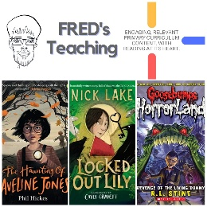 | 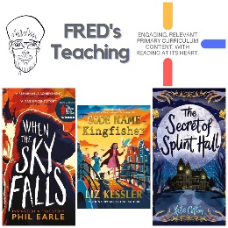 | 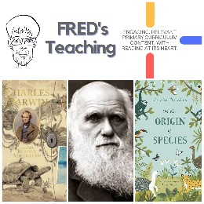 | 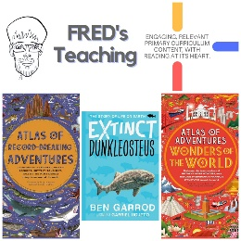 | 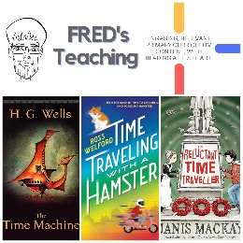 | 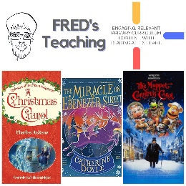 | 